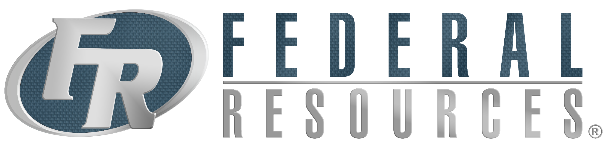

FOR IMMEDIATE RELEASE

CONTACT

Kelly Huston

[Kelly.Huston@federalresources.com](mailto:Kelly.Huston@federalresources.com)

Jason Stallings

[Jason.Stallings@federalresources.com](mailto:Jason.Stallings@federalresources.com)

800-892-1099

**Federal Resources Completes Marley International Group Acquisition**

*The acquisition expands upon Federal Resources’ mission to provide quality products, create unique value, and capitalize on emerging and active markets.*

**Stevensville, MD (February 9, 2017)** – Federal Resources of Stevensville, Maryland has acquired Marley International Group, a global product marketing firm with focused operations in the Arabian Gulf.

Federal Resources, a prime supplier of defense and security solutions to the U.S. government, is expanding its presence to include allied nations where U.S. interests are served.

Marley International Group was founded as a multi-national partnership of professionals from the medical, defense, and energy industries. Specializing in all aspects of the contract selling process, the team of experts provides strategic advice to U.S. manufacturers who wish to expand in the Arabian Gulf.

Robert McWilliams, CEO of Federal Resources, announced to shareholders and employees that the acquisition is imperative in following the company’s strategic efforts to expand upon its global reach and continually enhance the key product and service solutions for which the company is known. “We believe the Marley acquisition gives us tremendous reach and insight into emerging markets vis-a-vis its established customer and agent base.”

“Marley International has built a strong network of relationships and established product pipelines in key markets that will continue to propel and position Federal Resources as an internationally known solutions provider,” says Marley International’s Managing Director, David Loeser.

Terms of the transaction were not disclosed but Federal Resources reported they would merge operations in its Stevensville, Maryland headquarters and potentially establish offices abroad.

**About Federal Resources**

Founded in 1986, Federal Resources provides mission critical solutions to United States Military, Department of Defense, Federal Government, and State and Local responder markets. The company integrates expertise in innovative technologies, best practices in business procurement, comprehensive technical services, and training into a total life-cycle solution to support and sustain the warfighter and first responder.

**About Marley International Group**

Marley International Group is a multi-national partnership of professionals from the medical, defense, and energy businesses. Providing comprehensive approaches to its clients, the company specializes in all aspects of the contract selling process to include trade compliance (ITAR/EAR/FCPA), banking and trade finance, contract negotiation, export services, transport, and bilateral relationship building. Marley International Group operates in the continental U.S. and the Arabian Peninsula.