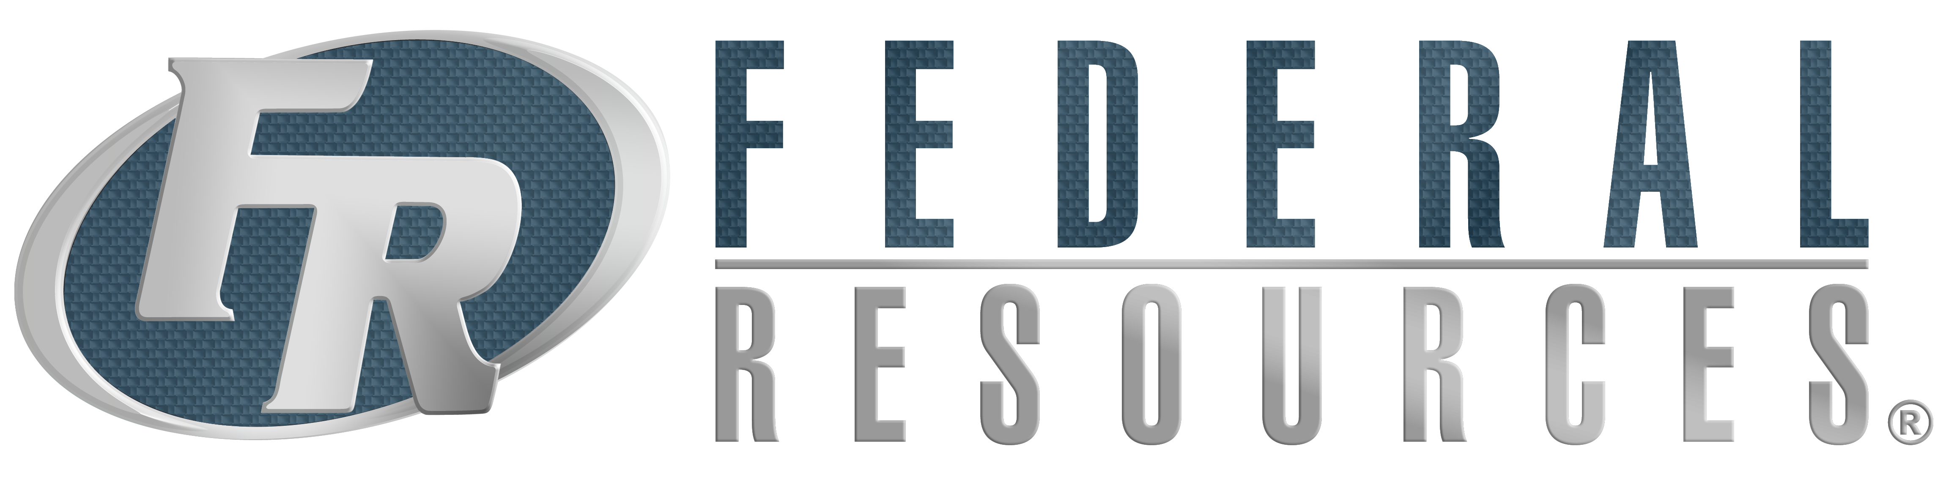

FOR IMMEDIATE RELEASE

CONTACT

Jason Stallings

[Jason.Stallings@federalresources.com](mailto:Jason.Stallings@federalresources.com)

800-892-1099

**Federal Resources Offers More Than an Expo at 5th Annual ExperienceFR Event**

*The event will be highlighted by guest speaker, Medal of Honor Recipient and New York Times Best Selling Author, Sergeant Dakota L. Meyer.*

**Stevensville, MD (November 29, 2017)** – Federal Resources is hosting its 5th annual ExperienceFR event on December 6, 2017 in Washington, D.C. ExperienceFR is an exhibition of products and solutions for military, first responders, and law enforcement professionals.  The event will feature training, demonstrations, book signings, and a prominent guest speaker to offer attendees a truly one-of-a-kind experience in a more intimate environment offered by standard tradeshows.

The event will be highlighted by guest speaker Sergeant Dakota L. Meyer, a United States Marine Corps veteran and recipient of the Medal of Honor – the military's highest honor. Meyer is also a *New York Times* best-selling author of *Into the Fire: A Firsthand Account of the Most Extraordinary Battle in the Afghan War*. The first living Marine to have received the Medal of Honor since 1973, and one of the youngest, Meyer will speak to his experiences in Afghanistan and how inspiration, motivation, courage, leadership, believing in yourself, and doing what is right has since shaped his life.

Made possible through the sponsorships of RAE Systems by Honeywell and media partner, CBRNe World, ExperienceFR will include displays of products and solutions from more than 50 suppliers. On-site exhibitors include 908 Devices, Airboss Defense, Cobham, First Line Technologies, Germane Systems, Holmatro, Husqvarna, Motorola Solutions, RAE Systems by Honeywell, SKB Cases, Thermo Scientific, and many more.

Children’s National Health System, based in Washington, D.C., has been selected as the event’s charitable partner. Contributions made during the exhibition will be matched by Federal Resources and benefit the hospital’s Cancer Research and Child Life Services.

**ExperienceFR**

Wednesday, December 6, 2017

8:00 AM – 4:00 PM

Marriott Wardman Park

2660 Woodley Road, NW

Washington, D.C. 20008​

To register for a complimentary pass to ExperienceFR, please visit [www.experiencefr.com.](http://www.experiencefr.com/)

**About Federal Resources**

Founded in 1986, Federal Resources is a leading provider of quality products and mission-critical solutions that support the U.S. Military, Federal Government, State/Local Responders, and International Markets. Specializing in comprehensive life-cycle sustainment solutions; procurement and acquisition; technical services and asset management; and training expertise, the organization is dedicated to serving its diverse range of well-established and emerging market segments. Federal Resources strives to fulfill and expand upon its mission to ensure end-users are equipped with the most innovative, reliable, and cost-effective products and technologies available on the market.

For more information, visit [www.federalresources.com](http://www.federalresources.com).